**JAYPEE UNIVERSITY OF ENGINEERING & TECHNOLOGY**

UX/UI LAB



LAB RECORD FILE

2019-2020

Submitted By: Bonthu Avinash Chowdary(181b072)

Submitted To: Mr. Dinesh Kumar verma

**INDEX**

|  |  |
| --- | --- |
| **Lab Exercise** | **Page number** |
| Lab-1: Flowchart designing | 3 |
| Lab-2: Learning various tools of Photoshop | 4 |
| Lab-3: Photoshop based Exercise | 5 |
| Lab-4: Illustrator based Exercise-1 | 7 |
| Lab-5: Illustrator based Exercise-2 | 8 |
| Lab-6: Windows Live Movie Maker | 10 |
| Lab-7: HTML Webpage Design | 10 |
| Lab-8: Webpage Hosting | 10 |

**Lab Exercise -1**

**Flowchart 1:**

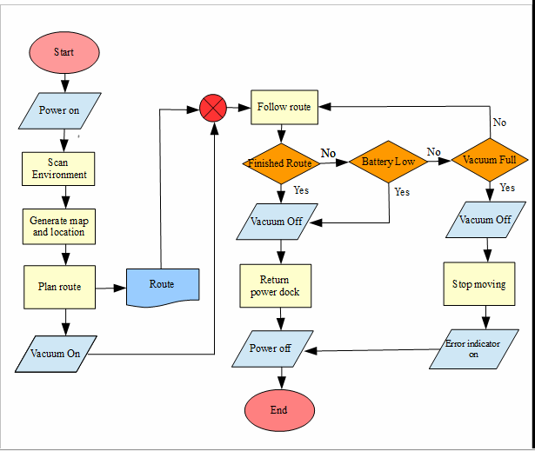

**Flowchart 2:**

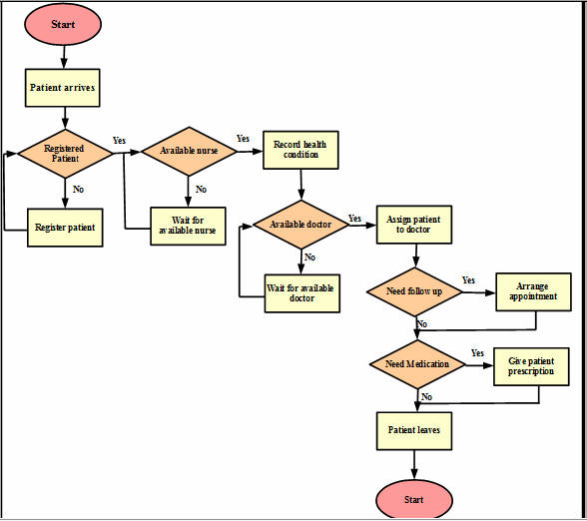

We made these flowcharts with the help of Microsoft Office Picture Manager

**Lab Exercise -2**

**Learning various tools of Photoshop:**

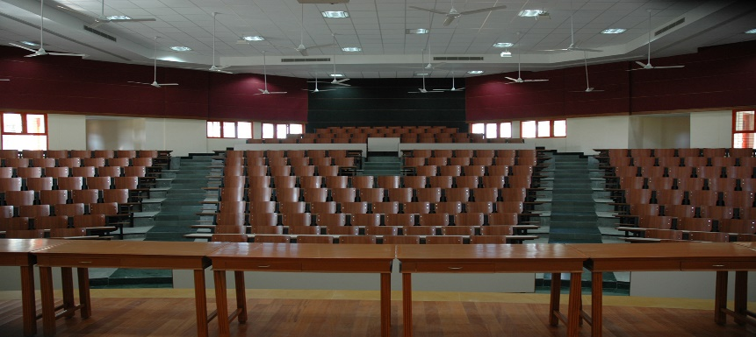

1. Image Resize

(Image-🡪Image Size)

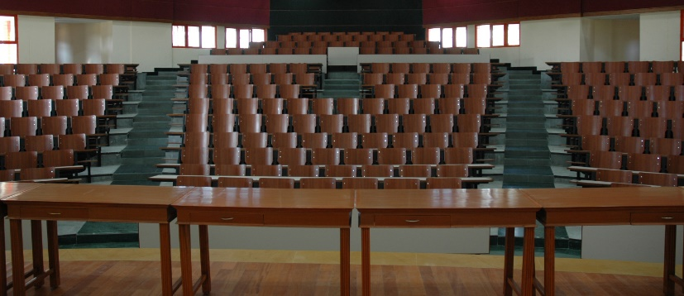

1. Image Crop Tool

(Press C to select Crop tool select it from the Tool box panel)

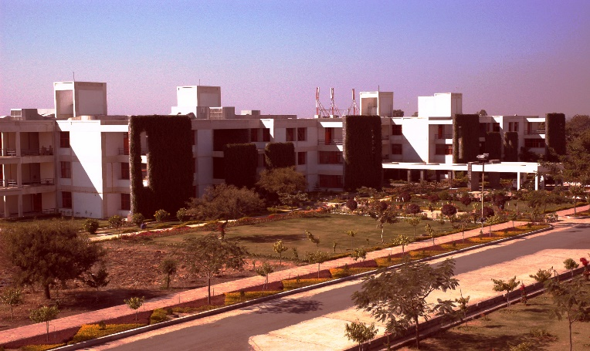

1. Image Color Manipulation

(Image--🡪Adjustments)

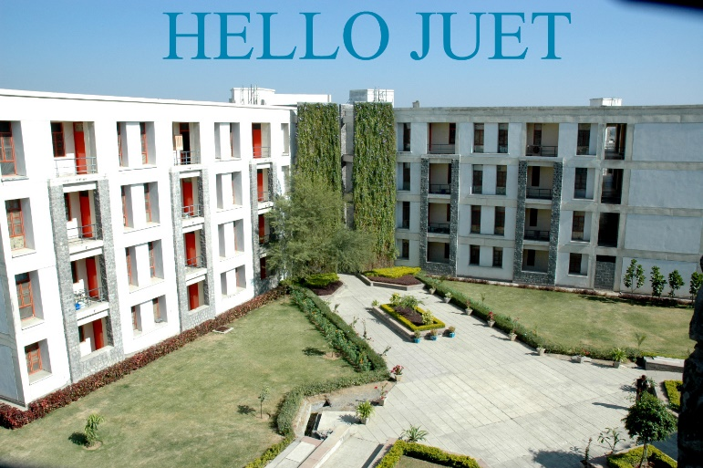

1. Text Editing on Image

(Press T to select or Click on T on the Tool box panel)

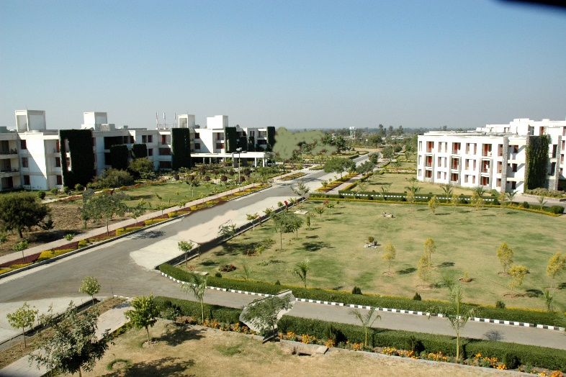

1. Moving a particular portion from one location to another location

(Use Lasoo tool or magic band tool to select and then use Move tool)

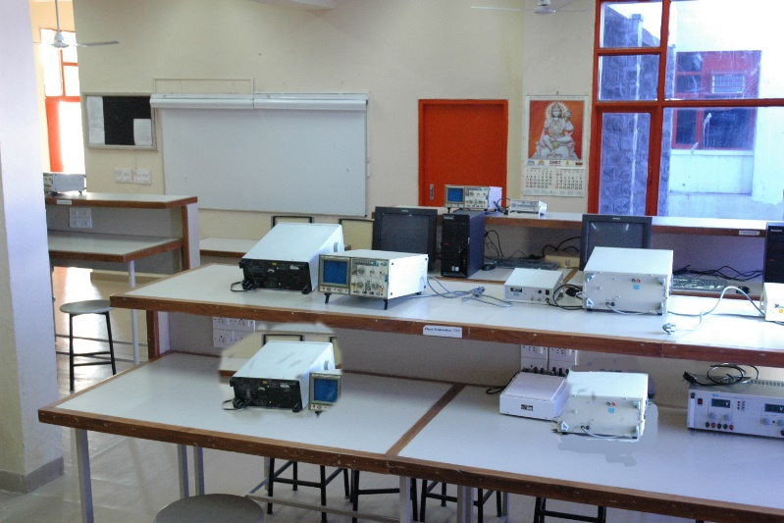

1. Image Clone tool

(Press S to select Clone tool or select it from the Tool box panel)

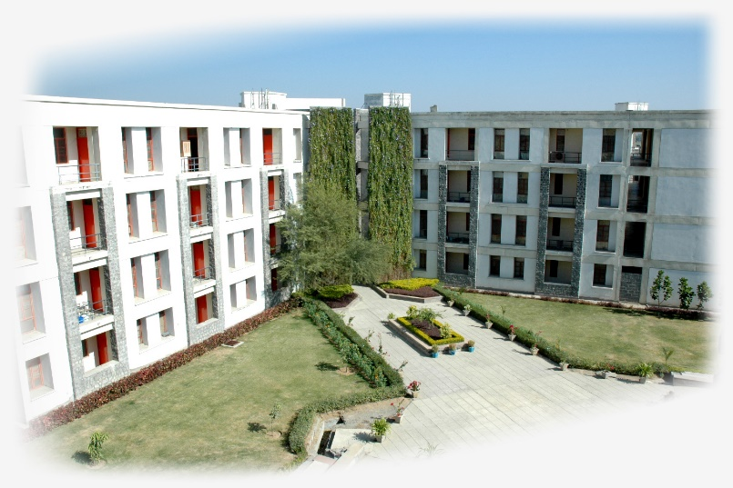

1. Background color editing

(Use Paint Bucket Tool by pressing G or select it from the Tool box panel. Also use Eraser tool for it)

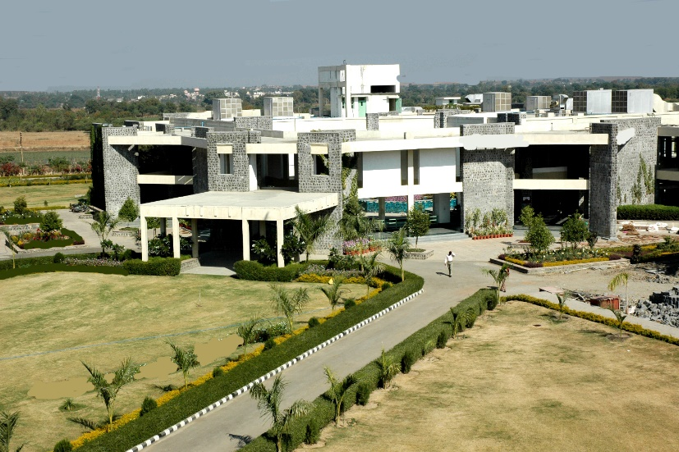

1. Eraser Tool

(Press E to select or select it from the Tool box panel)

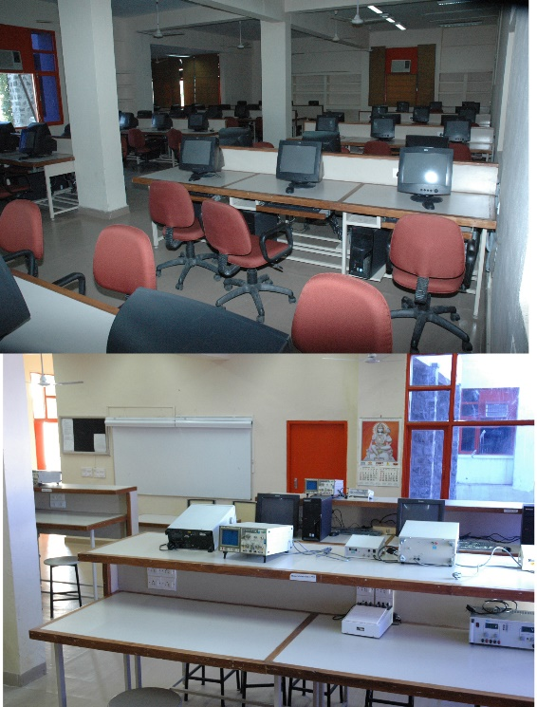

1. Concatenation of two images or more than two images in a single file

(Open both the file which is to be concatenated. Now open a new file having size equal to size of both the images (image1+image2))

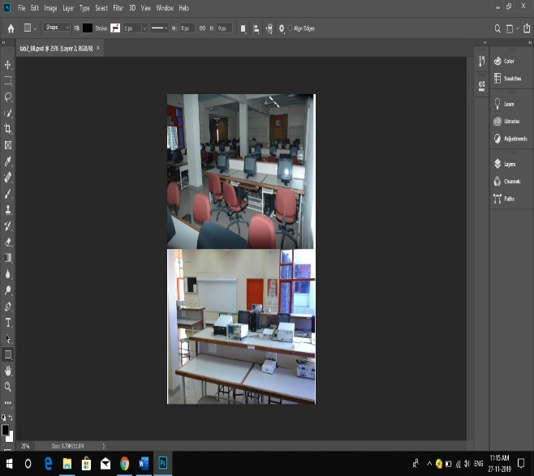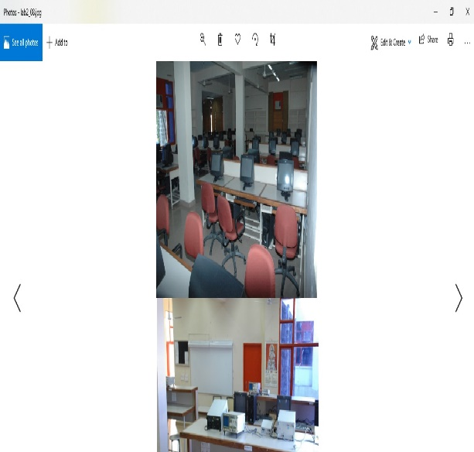

1. Saving images in different format like psd, jpeg etc.

**Lab Exercise -3**

**Photoshop based exercise**

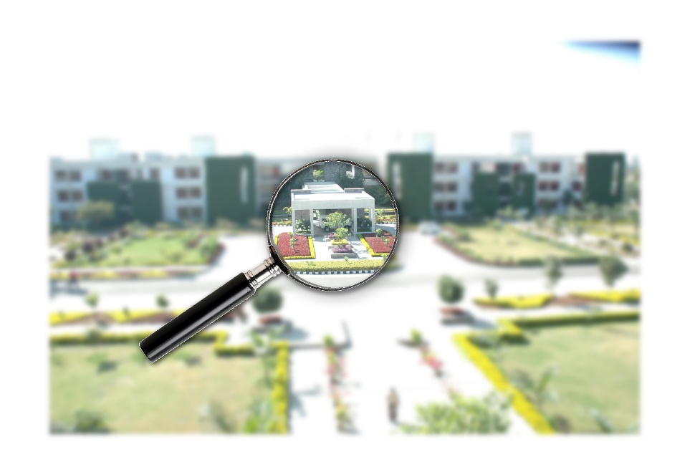

1. **Magnifying Glass + Content Blur**
2. Open magnifying glass image. Note that the attached magnifying glass is a GIF file, which has a colour mode of INDEXED COLOR. After you have opened the file, Go to Image > Mode > RGB Colour. This is important as Indexed colour leaves you with limited photoshop options and filters. Now we will open an image that we want to magnify.
3. Now we will open an image that we want to magnify. Move magnifying glass to the image and place it on the portion that you want to magnify as it is illustrated below:Now using the magic wand tool, click on the inside area of the glass that we would like to magnify.
4. Now select background layer and press CTRL + J to duplicate the selection to a new layer. Rename the duplicate layer to Focus. Now double click on Background layer. A new window will open in which its name would appear as “Layer 0”. Click ok to unlock the background layer. Now press CTRL+T on a PC to transform this layer - shrink it by about 85% .We are now going to blur the background image. Take that layer (Background layer) that you just shrunk and go to Filter > Blur > Gaussian Blur with a radius of about 5 pixels. We now have focus area. Let’s add some depth. Select your magnifying glass (Layer 1). Right click on Layer 1 and go to the blending options. Check drop shadow and click on it. Set the drop shadow with the following values.

**2b) Photo Manipulation- Hair Colouring**

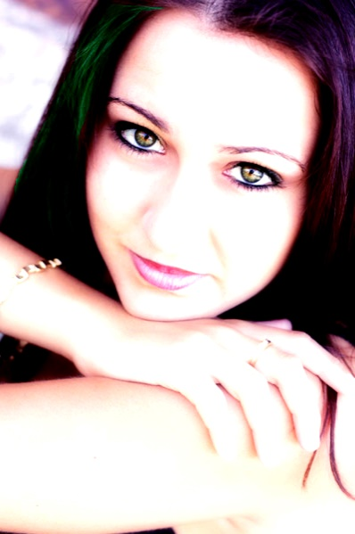

1. Open an image that you would like to manipulate. In this case we are going to use a photo of a girl with fine hair. Duplicate the layer, place it on the top and ensure you are working on the duplicated layer through the rest of this project.
2. We will use the Magic Lasso tool and create paths around the area we would like to manipulate.
3. Let’s work on one side of her hair. This way we can compare what we have done with the other side.
4. We will now apply hue/saturation to our image. To show the huge change, I will be using a very funky colour.
5. Make sure you click on colorize and use whatever colour setting you like, below is an example of what I will be using.
6. After you press 'OK' this is what we get with hue/saturation.

**2c) Water Reflections Photoshop Text Effect**:

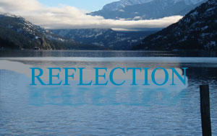

1. Open an image of a lake or ocean that you would like to manipulate. Make sure your image is in RGB mode. To check this, go to Image under the menu bar > Mode > RGB Colour. Type in your desired text using a thick font.On your text layer. Right click and select Rasterize Text to convert the text to a graphic.
2. Make a duplicate of this layer.
3. We are now going to flip the duplicated layer. Select the duplicated layer. From the edit menu go to Transform > Flip Vertical. We will also need to transform the height for this layer. Go to the Edit Menu > Transform > Distort. Transform the Height to 75% the original size.
4. Make sure your layer is still selected then go to the Filter Menu > Distort > Ripple with a value of 300 or as per the requirement.
5. We are now going to add a motion blur. To do this go to Filter > Blur > Motion Blur with angle of 0 degrees and distance of 15.
6. Finally, change the opacity of the rippled layer to 60 percent.

**Lab Exercise -4**

**In this Exercise, student will create an illustration of a pear pierced by an arrow.**

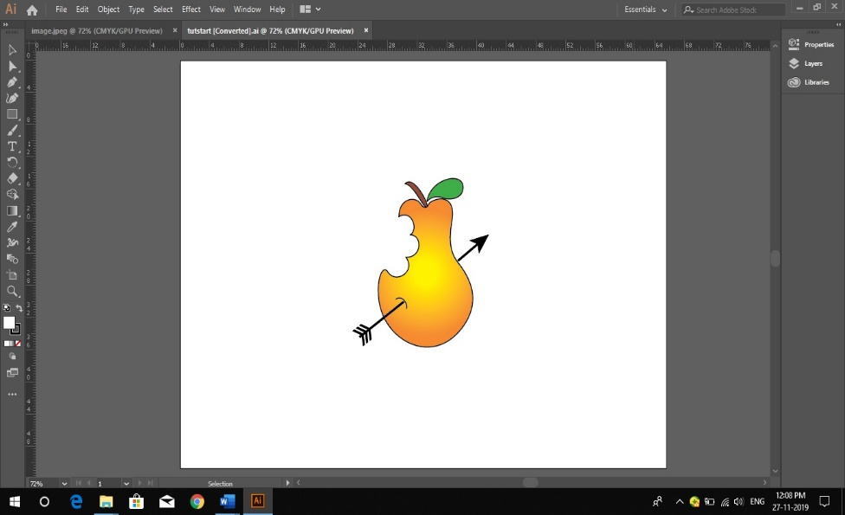

1. Choose View > Hide Bounding Box to hide the bounding boxes of selected objects. Select the pen tool () in the toolbox, and move the pointer to the dashed line of the arrow in the artwork.
2. Click point A at the left end of the line to create the starting anchor point—a small solid square. (Notice that the pen tool pointer has a small x next to it. This indicates that clicking will begin a new path.)
3. Click point B at the right end of the line to create the ending anchor point. (When you click a second time, a caret (^) appears next to the pen tool. The caret indicates that you can split the anchor point to create a direction line for a curve by dragging the pen tool from this anchor point. The caret disappears when you move the pen tool away from the anchor point.) You must end the path before you can draw other lines that aren’t connected to the path. Now you’ll make the straight line thicker by changing its stroke weight.

**Lab Exercise -5**

1. **Drawing a Pencil using Illustrator**

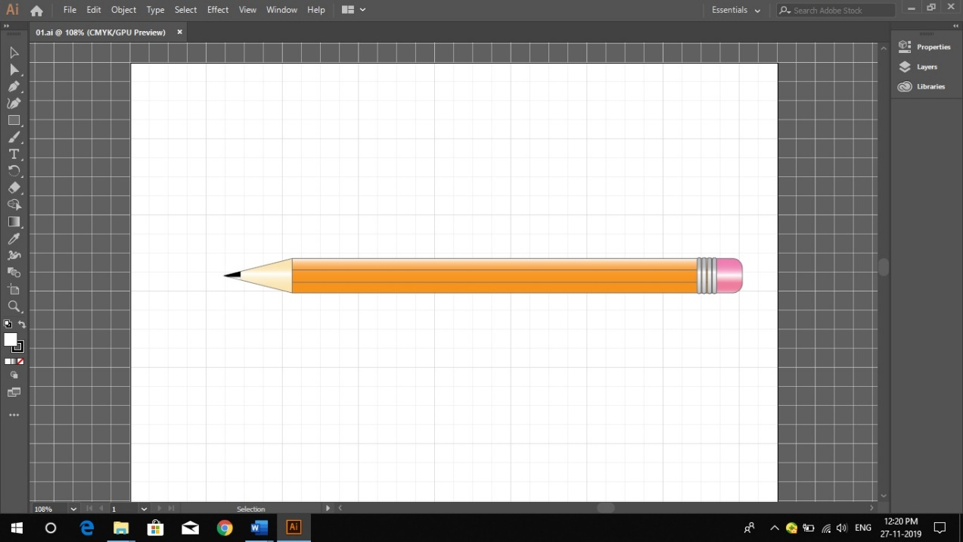

1. Click on the rectangle tool in the toolbar to activate it and click once on the art board to open the rectangle options.
2. Enter 514 pixels for the width and 42 pixels for the height.
3. Click OK, and the rectangle appears on the artboard.
4. Leave the pencil's rectangle selected and change the fill to a gradient, and the stroke to black.
5. Set the stroke width to 0.5 in the stroke palette.
6. Open the Gradient palette and set the type to linear, and the angle to -90°. (Make sure colour mode in the pop up menu of colour Palette is set to RGB for all gradient stops in Gradient Palette)
7. Set the left gradient stop to Red 237-Green 135-Blue 0.
8. Set the right gradient stop to Red 255-Green 204-Blue 51.
9. Click on the Line tool in the toolbar and then click once on the artboard to open the line options. Enter 514 pixels for the length and 0° for the angle. Click OK. Copy and paste it so you have two lines.
10. **Drawing a Multimedia Player Button**

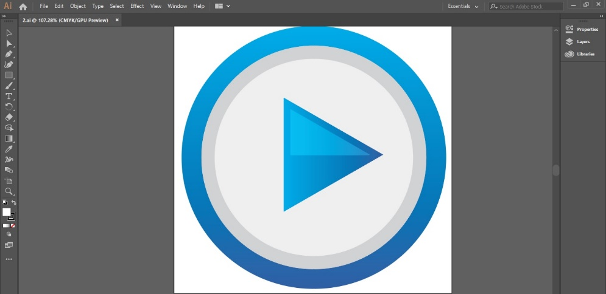

1. Open a new document with 420 pixels by 420 pixels. Activate Smart Guides in View Menu (Ctrl + U). Draw a circle with an Ellipse Tool 400 pixels width and 400 pixels height.
2. Fill the circle with a linear gradient with colours from R=38, G=169, B=224 to R=43, G=56, B=143.
3. With Circle selected go to Object > Path > Offset to open the Offset Path dialog. Change the Offset to -30 pixels and press OK.
4. Fill the smaller circle with a linear gradient with Grayscale colour 20% Set the angle to -90 degree.
5. Now with Smaller Circle selected go to Object > Path > Offset to open the Offset Path dialog. Change the Offset to -0 pixels and press OK.
6. Don’t change the colour of the smallest circle, only change the gradient angle to 90 degree.
7. Select all circles and group them. Draw a triangle with Star Tool (Available in Drawing tool like rectangle, circle etc.) that is 100 pixels width Radius 1- and 100-pixels Radius 2, Points – 3, press OK.
8. Rotate (Object->Transform-->Rotate) the Triangle to -90 degree, press OK.
9. Place the Triangle at the centre of Circles. Select Triangle and with Eyedropper Tool click on the biggest circle that is blue gradient. Change the gradient angle to 90 degree.
10. With Triangle selected go to Object > Path > Offset to open the Offset Path dialog. Change the Offset to -10 pixels and press OK.
11. Draw a rectangle that intersects the triangle. With rectangle and triangle selected press the Subtract from Shape Areas button in the Pathfinder Panel.
12. Fill it with a linear gradient with colours white and black, change the gradient angle to -90 degree. Last step, change the transparency to Screen Mode.
13. You can download .ai and .eps formats below.

**Lab Exercise -6**

**Develop a Movie using Windows Live Movie Maker**

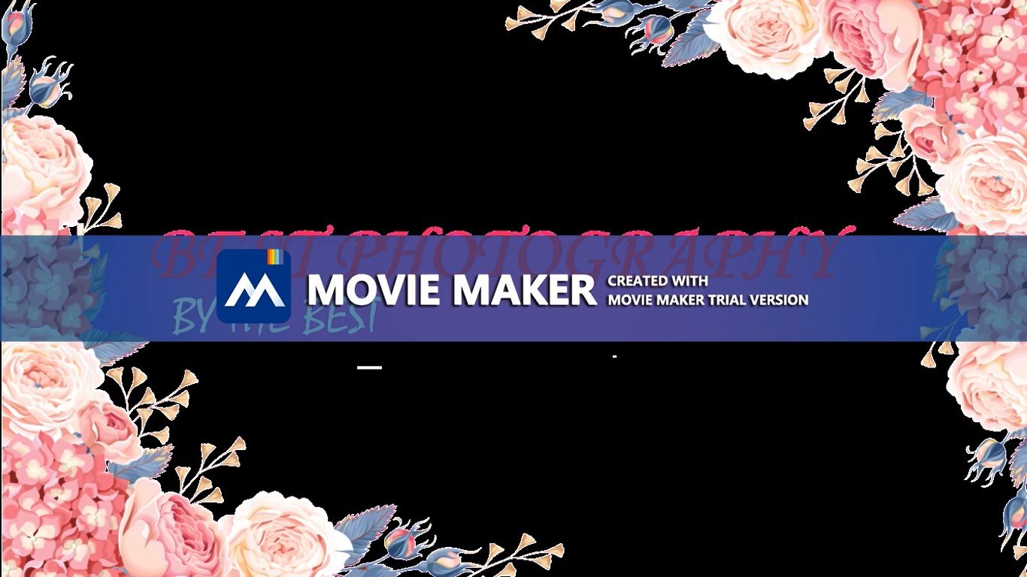

**Lab Exercise -7**

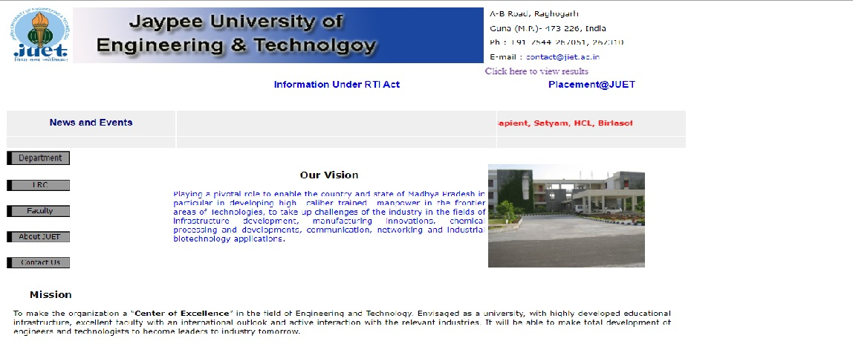

**Introduction to basics of**

**Website and designing**

**a framework and**

**developing a website**

**Lab Exercise -8**

**Hosting website designed in previous exercise on intranet**

We Hosted the webpage we designed on our local server and also hosted the same on two network portals. For this we used IIS, XAMPP and Tomcat applications.